Wilmington NC- coastal city

TUE  JAN 15 | Sunny | 51°30° | 10% | NNW 7 mph | 62%
WED  JAN 16 | Sunny | 58°33° | 10% | W 7 mph | 61%
THU  JAN 17 | Mostly Cloudy | 58°44° | 10% | ESE 7 mph | 68%
FRI  JAN 18 | Partly Cloudy | 62°45° | 10% | W 8 mph | 72%
SAT  JAN 19 | Partly Cloudy | 65°59° | 10% | SE 9 mph | 74%
SUN  JAN 20 | Rain | 64°24° | 80% | WSW 15 mph | 71%

Hickory NC- inland city

TUE  JAN 15 | Partly Cloudy | 49°28° | 10% | WNW 3 mph | 59%
WED  JAN 16 | Mostly Sunny | 55°32° | 0% | WSW 4 mph | 52%
THU  JAN 17 | PM Light Rain | 48°39° | 70% | SE 4 mph | 69%
FRI  JAN 18 | Partly Cloudy | 59°41° | 10% | WNW 4 mph | 73%
SAT  JAN 19 | Showers | 54°46° | 70% | SSE 6 mph | 85%
SUN  JAN 20 | AM Showers | 53°16° | 60% | NW 13 mph | 63%

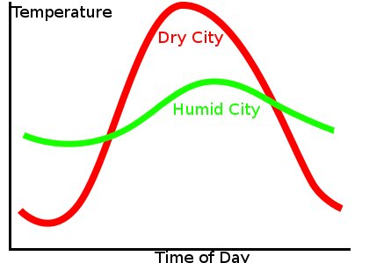
Coastal City
Inland City

