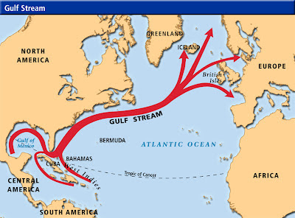

The Gulf Stream is a warm ocean current in the Atlantic Ocean. It flows northeast along the eastern coast of the United States. The Gulf Stream helps keep weather along the eastern coast mild by warming the air and land during the cooler months.

