Which One: Heat Transfer Classwork
Identify the method of heat transfer for each example below. Record the words conduction, convection, or radiation on your notebook paper.
1. Your hand stirring a spoon in a cup of hot tea | 2. Heating water in a tea kettle  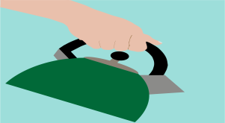
3. Lava lamp with liquids rising and falling  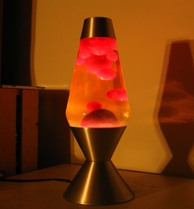 | 4. Warming your hands near a fire  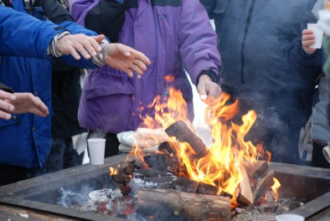
5. Ironing clothes | 6. Hot air balloon  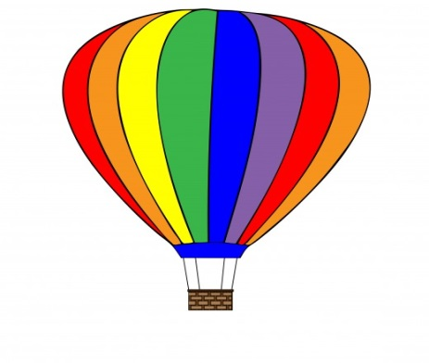
7. In a swimming pool, the water near the surface is warmer | 8. Popping popcorn in the microwave  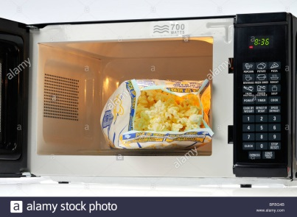
9. Cooking in a toaster oven  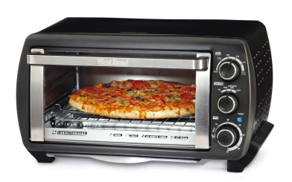 | 10. Hot air blowing from a blow dryer  