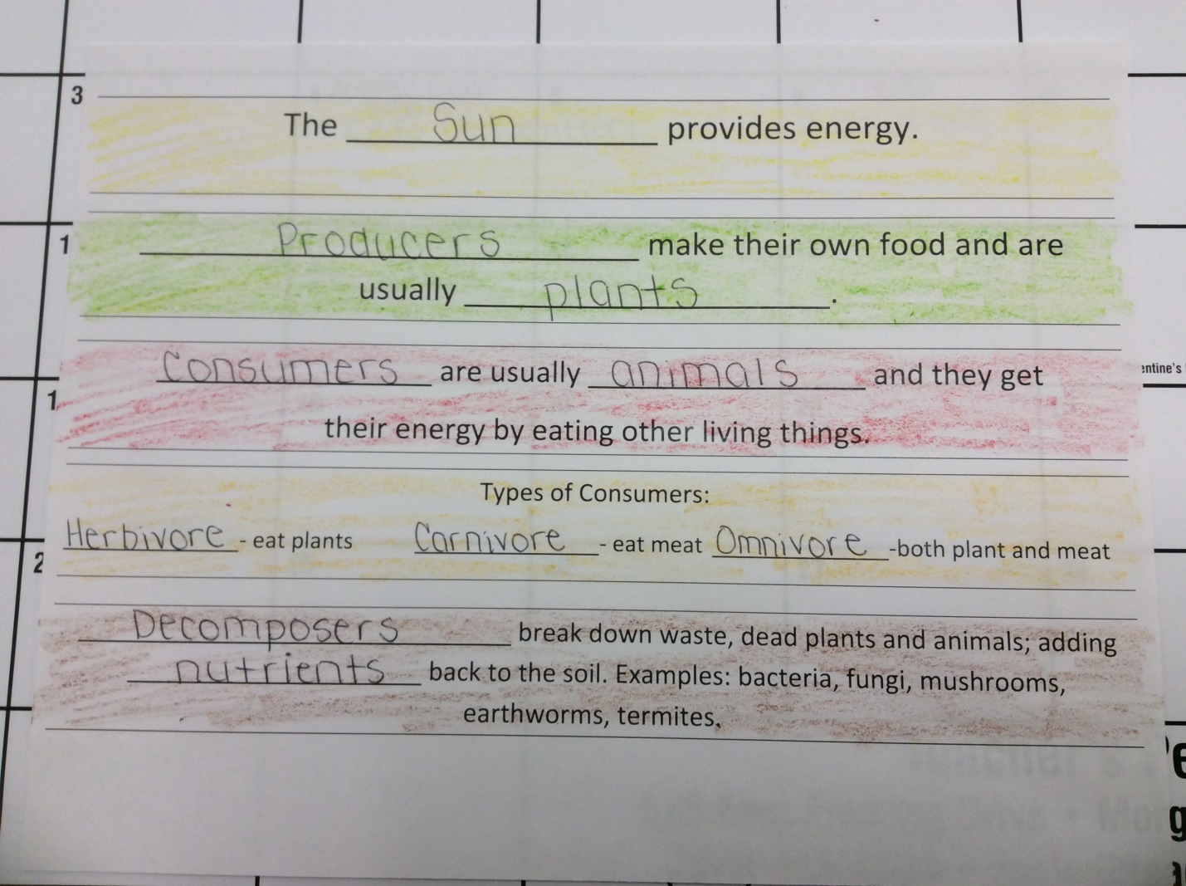
Yellow
Green
Red
Orange
Brown

