CONSERVATION OF MASS CLASSWORK
1. | 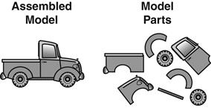  Irving received two of the same model trucks. He assembled one and left the second model in its parts.  Which balance BEST shows how the assembled model compares to its parts?
 | A.
 | B.
 | C.
 | D.

2. | A student pours ¼ cup of salt on a scale. The student then puts 3 cups of water in a container on the scale, and records the weight of the salt and the container of water. The student pours the salt into the container of water, and waits for it to dissolve. The student then weighs the salt and water solution. Which of the following best describes the weight of the salt and water mixture compared to the weight of the salt and water before they were mixed?
 | A. The weight of the salt and water mixture will be the same, because the mass of the salt and the mass of the water did not change.
 | B. The weight of the salt and water mixture will be less, because the salt lost some of its mass when it dissolved.
 | C. The weight of the salt and water mixture will be more, because the salt molecules will inflate, causing the mass to increase.
 | D. The weight of the salt and water mixture will be more because the water absorbes the salt, which increases in mass.

3. | Drayton is making paper air planes. He uses 10 grams of paper to make 20 paper airplanes. If he weighs the paper airplanes, which is their total mass?
 | A. 30 grams
 | B. 10 grams
 | C. 20 grams

4. | Figure 1 diagram shows an ice cube in a cup. Figure 2 shows the ice cube melted to water in the cup.  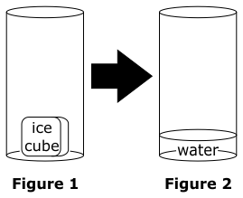  Which property of the ice cube remains the same both before and after it melted?
 | A. color
 | B. shape
 | C. weight
 | D. temperature

5. | Jacob cuts a one-pound block of cheese into four slices. What is the weight of the cheese after it is sliced?
 | A. 1/4 pound
 | B. 1 pound
 | C. 2 pounds
 | D. 4 pounds

6. | A student notices that an inflated balloon gets larger when it is warmed by a lamp. Which best describes the mass of the balloon as a result of this change?
 | A. The mass of the balloon increases because the size of the balloon has increased.
 | B. The mass of the balloon increases because the temperature of the balloon has increased.
 | C. The mass of the balloon stays the same because the gas inside the balloon still has the same mass after it warms up.
 | D. The mass of the balloon stays the same because warming decreases the mass enough to cancel out the effect of increasing the size.
7. | A student is comparing the mass of a model airplane to its parts. She places the completed model airplane on one side of the balance.  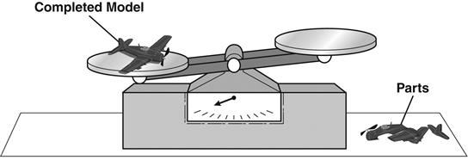  Which picture BEST shows the direction of the pointer when the parts are added to the other side of the balance?
 | A.
 | B.
 | C.
 | D.

8. | Chris fit the pieces of a space shuttle model together.  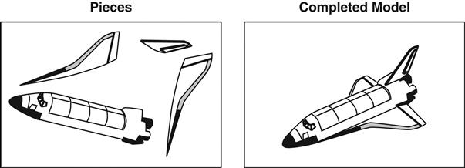  Which statement BEST describes how the pieces compare to the completed model?
 | A. Each piece is stronger than the completed model.
 | B. The mass of the completed model equals the mass of all the pieces.
 | C. Each piece is made from a different material than the completed model.
 | D. The mass of the completed model is more than the mass of the all the pieces.
9. | Zamora cuts up 40 g of strawberries, 50 g of cantaloupe, and 70 g of pineapple into a bowl. Which best describes the amount of fruit salad in the bowl?
 | A. 90 g
 | B. 120 g
 | C. 160 g
10. | A swing set has a mass of 235 kilograms (kg).  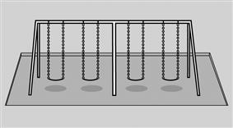  The chains connected to the seats have a combined mass of 35 kilograms (kg) and the frame has a mass of 190 kilograms (kg). What is the combined mass of the seats?
 | A. 10 kilograms
 | B. 15 kilograms
 | C. 25 kilograms
 | D. 30 kilograms

