Weather Tools and Pressure Systems Vocabulary Quiz

1. A strong low-pressure weather system forms off the coast and moves toward a land area. Which weather conditions will likely result from the low-pressure system?
A. clear, sunny skies and calm winds
B. mostly sunny skies with little to no precipitation
C. partly cloudy skies with little precipitation and light winds
D. mostly cloudy skies with moderate to heavy precipitation and strong winds
2. The forecast said a high pressure system will arrive this weekend. Jacob and his friends want to go camping. Should they plan to go?
A. Yes, the high pressure system will create clear, sunny skies.
B. No, the high pressure system will create storm clouds and tornadoes.
C. Yes, the high pressure system will create hot weather.

3. On Friday, the weather is cold and cloudy. On Saturday, the weather is sunny and warm. Which change most likely occurred from Friday to Saturday?
- from high to low temperature
- from low to high air pressure
- from low to high wind speed
- from low to high amounts of rain

4. Which instrument is best used to predict weather changes?
A. a hygrometer
B. an anemometer
C. a thermometer
D. a barometer

5. On a cold, cloudy day, the local weather forecaster predicts that a high pressure system will be moving into the area in the next 24 hours. Which weather conditions will this system most likely bring to the area?
A. stormy
B. sunny
C. snowy
D. hot

 | Science tool Name | What the tools measures
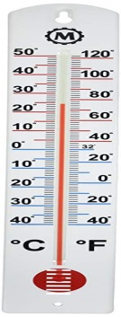 | 6.  a. barometer  b. rain gauge  c. thermometer  d. wind/weather vane  e. anemometer | 7.  a. temperature  b. air pressure  c. wind direction  d. wind speed  e. the amount of rain/snow fall
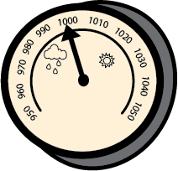 | 8.  a. barometer  b. rain gauge  c. thermometer  d. wind/weather vane  e. anemometer | 9.  a. temperature  b. air pressure  c. wind direction  d. wind speed  e. the amount of rain/snow fall
 | 10.  a. barometer  b. rain gauge  c. thermometer  d. wind/weather vane  e. anemometer | 11.  a. temperature  b. air pressure  c. wind direction  d. wind speed  e. the amount of rain/snow fall
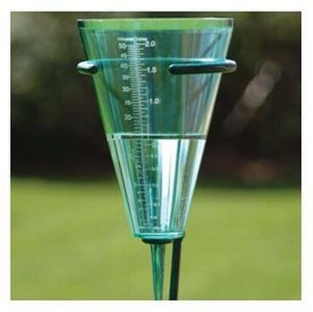 | 12.  a. barometer  b. rain gauge  c. thermometer  d. wind/weather vane  e. anemometer | 13.  a. temperature  b. air pressure  c. wind direction  d. wind speed  e. the amount of rain/snow fall
 | Science tool Name | What the tools measures
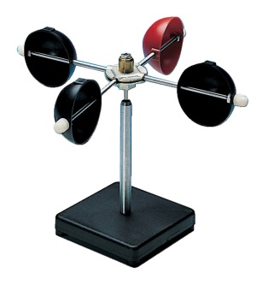 | 14.  a. barometer  b. rain gauge  c. thermometer  d. wind/weather vane  e. anemometer | 15.  a. temperature  b. air pressure  c. wind direction  d. wind speed  e. the amount of rain/snow fall

